MongoDB Query

Also available on PowerPoints by Nasim

# Topics

1 ad-hoc queries using find and findOne

2 Query for

Range

Set inclusion

Inequalities

FIND

Already done a few

Move to mydb

Create a collection blog and insert one piece of data

db.blog.insertOne (

{

"_id" : ObjectId("5037ee4a1084eb3ffeef7228"),

"title" : "My Blog Post",

"content" : "Here's my blog post.",

"date" : ISODate("2012-08-24T21:12:09.982Z")

}

)

db.blog.insertOne (

{

"title" : "My Blog Post 2",

"content" : "Here's my blog post 2.",

}

)

FIND (cont'd)

The *find* function is called to query and see documents in a collection. It returns a subset of documents.

To see documents in *blog* collection:

db.blog.find()

Or

db.blog.find({})

The following output is the result of calling the find function collection:

{ "_id" : ObjectId("5037ee4a1084eb3ffeef7228"), "title" : "My Blog Post", "content" : "Here's my blog post.", "date" : ISODate("2012-08-24T21:12:09.982Z") }

{ "_id" : ObjectId("5fb6d40060924ef8e582c389"), "title" : "My Blog Post 2", "content" : "Here's my blog post 2." }

> **db.blog.find({}).pretty();**

{

"_id" : ObjectId("5037ee4a1084eb3ffeef7228"),

"title" : "My Blog Post",

"content" : "Here's my blog post.",

"date" : ISODate("2012-08-24T21:12:09.982Z")

}

{

"_id" : ObjectId("5fb6d40060924ef8e582c389"),

"title" : "My Blog Post 2",

"content" : "Here's my blog post 2."

}

findOne

Shows only one document.

If you run it again it will show the same document

db.blog.findOne()

{

"_id" : ObjectId("5037ee4a1084eb3ffeef7228"),

"title" : "My Blog Post",

"content" : "Here's my blog post.",

"date" : ISODate("2012-08-24T21:12:09.982Z")

}

Query with Key/Values Pairs

* We can add key/value pairs to restrict the search.
  + Members match members
  + Booleans match Booleans
  + Strings match strings
* Example:

1 Find all documents where the value of age is 20:

db.users.find({"age" : 20})

We have not loaded any

2 Search for documents where the username is “joe”

db.users.find({"username" : "joe"})

Find with multiple conditions

Simply add more conditions

Example:

We want to find users where their age is 20 and the username is “joe”:

> db.users.find({"username" : "joe", "age" : 27})

To find items which are out of stock:

> db.stock.find({"in_stock" : 0})

find some

Limit the Keys/Values to see

First -- Adding another collection 🡺 Employee

Done by an array, but not needed yet

var myEmployee=

[ {

"Employeeid" : 1,

"EmployeeName" : "Smith"

},

{

"Employeeid" : 2,

"EmployeeName" : "Mohan"

},

{

"Employeeid" : 3,

"EmployeeName" : "Joe"

},

];

db.Employee.insert(myEmployee);

Display json

**db.Employee.find().forEach(printjson)**

**Code Explanation:**

1. The first change is to append the function called for Each() to the find() function. What this does is that it makes sure to explicitly go through each document in the collection. In this way, you have more control of what you can do with each of the documents in the collection.
2. The second change is to put the printjson command to the forEach statement. This will cause each document in the collection to be displayed in JSON format.

If the command is executed successfully, the following Output will be shown

**Output:**

[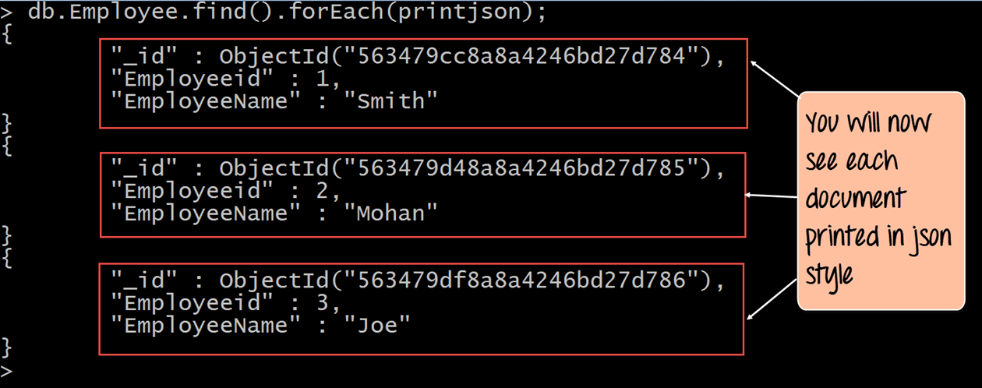](https://www.guru99.com/images/MongoDB/112115_0607_Introductio10.png)

PRIMARY KEY

### What is Primary Key in MongoDB?

In MongoDB, _id field as the primary key for the collection so that each document can be uniquely identified in the collection. The _id field contains a unique ObjectID value.

By default, when inserting documents in the collection, if you do not add a field name with the _id in the field name, then MongoDB will automatically add an Object id field as shown below

**How to not have the default key**

db.Employee.insert({_id:10, "EmployeeName" : "Smith"})

**Now do a find**

> db.Employee.find().forEach(printjson)

{

"_id" : ObjectId("5fb6d84a60924ef8e582c38a"),

"Employeeid" : 1,

"EmployeeName" : "Smith"

}

{

"_id" : ObjectId("5fb6d84a60924ef8e582c38b"),

"Employeeid" : 2,

"EmployeeName" : "Mohan"

}

{

"_id" : ObjectId("5fb6d84a60924ef8e582c38c"),

"Employeeid" : 3,

"EmployeeName" : "Joe"

}

{ "_id" : 10, "EmployeeName" : "Smith" }

Queries with Criteria

**Range**

**OR clauses**

**And Negation**

**Range**

**Done the same as any language just the operators are a bit different**

Comparison operators:

|  |  |
| --- | --- |
| **Operators** | **Description** |
| “$lt” | < |
| “$lte” | <= |
| “$gt” | > |
| “$gte” | >= |
| “$ne” | <> |

The "$ne" operator can be used with any type.

Conditional Examples

The comparison operators can be combined to create range queries.

The following query look for employees with and Employeeid more than 2

db.Employee.find({Employeeid : {$gt:2}}) --- not a big problem at first is all the bracketing

{ "_id" : ObjectId("5fb6d84a60924ef8e582c38c"), "Employeeid" : 3, "EmployeeName" : "Joe" }

**More than one operator**

db.Employee.find({Employeeid : {$gt:1 , $le:3}}) -- will show an error

correction:

db.Employee.find({Employeeid : {$gt:1 , $lt:3}})

{ "_id" : ObjectId("5fb6d84a60924ef8e582c38b"), "Employeeid" : 2, "EmployeeName" : "Mohan" }

**NOT EQUAL**

Look for employee not equal Mohan

db.Employee.find( {"EmployeeName" : {"$ne" : "Mohan"} } )

(aside: the bracketing needs to be looked at carefully)

{ "_id" : ObjectId("5fb6d84a60924ef8e582c38a"), "Employeeid" : 1, "EmployeeName" : "Smith" }

{ "_id" : ObjectId("5fb6d84a60924ef8e582c38c"), "Employeeid" : 3, "EmployeeName" : "Joe" }

{ "_id" : 10, "EmployeeName" : "Smith" }

LIMIT clause

How to limit the number of documents

db.Employee.find().limit(2)

{ "_id" : ObjectId("5fb6d84a60924ef8e582c38a"), "Employeeid" : 1, "EmployeeName" : "Smith" }

{ "_id" : ObjectId("5fb6d84a60924ef8e582c38b"), "Employeeid" : 2, "EmployeeName" : "Mohan" }

>